**Vivekanand Education Society’s Institute of Technology**

**Department of AI &DS Engineering**



**Subject: Social Media Analytics**

**Class: D16ad**

| **Roll No: 30** | **Name:** [**SUHANEE KANDALKAR**](mailto:2021.suhanee.kandalkar@ves.ac.in) |
| --- | --- |
| **Practical No:4** | **Title: Data Visualization** |
| **DOP:** | **DOS:** |
| **Grades:** | **LOs Mapped:** |
| **Signature:** |  |

**Title:** Social Media Data Visualization

**Aim:** To perform Exploratory Data Analysis and visualizationof Social Media Data for business using Power BI etc.

**Theory:**

### **Exploratory Data Analysis (EDA) and Visualization of Social Media Data for Business Using Power BI**

Social media data is an essential resource for businesses to understand customer engagement, sentiment, and trends. To make informed decisions, businesses must conduct **Exploratory Data Analysis (EDA)** and utilize **data visualization techniques** to derive actionable insights.

## **1. Techniques of Data Visualization**

Data visualization transforms complex datasets into meaningful graphical representations. Various techniques exist to analyze and present social media data, such as:

### **1.1 Bar Charts & Column Charts**

* Used to compare categorical data.
* **Example:** A bar chart comparing the number of likes, shares, and comments across different social media platforms (Facebook, Instagram, Twitter).
* **Use Case in Social Media Data:** Analyzing post engagement on various days of the week.

### **1.2 Line Charts**

* Show trends over time, useful for time-series data.
* **Example:** A line chart displaying the number of new followers gained daily.
* **Use Case in Social Media Data:** Tracking the trend of impressions and clicks on ads over a month.

### **1.3 Scatter Plots**

* Helps identify relationships between two variables.
* **Example:** Analyzing the correlation between ad spend and conversions.
* **Use Case in Social Media Data:** Determining if higher engagement leads to increased website visits.

### **1.4 Heatmaps**

* Used to visualize data density or concentration.
* **Example:** A heatmap showing the most active hours of social media users.
* **Use Case in Social Media Data:** Identifying peak engagement times for posting content.

### **1.5 Word Clouds**

* Displays word frequency in a dataset.
* **Example:** A word cloud from customer reviews or comments to identify popular topics.
* **Use Case in Social Media Data:** Understanding audience sentiment by analyzing frequently mentioned words in comments.

### **1.6 Pie Charts & Donut Charts**

* Represent proportions of categories.
* **Example:** A pie chart showing sentiment analysis results (positive, neutral, negative).
* **Use Case in Social Media Data:** Analyzing the percentage of different content types (text, image, video) posted by a brand.

### **1.7 Sentiment Analysis Charts**

* Uses bar charts or pie charts to display sentiment analysis data.
* **Example:** A sentiment distribution of customer comments showing 60% positive, 30% neutral, and 10% negative comments.
* **Use Case in Social Media Data:** Understanding customer perception of a new product launch.

### **1.8 Geographic Maps (Geo-Maps)**

* Displays data related to location.
* **Example:** A geo-map showing the distribution of followers by country.
* **Use Case in Social Media Data:** Identifying the most engaged regions for targeted ad campaigns.

## **2. Tools for Data Analysis and Data Visualization**

Various tools help in analyzing and visualizing social media data. Below are some commonly used tools:

### **2.1 Power BI**

* **Description:** A Microsoft-based business intelligence tool that provides interactive dashboards and advanced visualization.
* **Features:**
  + Supports multiple data sources (Excel, SQL, APIs).
  + Drag-and-drop interface for easy report building.
  + Provides real-time data analytics.
* **Use Case in Social Media Data:**
  + Creating **customized dashboards** displaying engagement trends, post reach, and audience demographics.
  + Performing **sentiment analysis visualization** to track customer perception.
  + Analyzing **advertisement performance** over time.

### **2.2 Tableau**

* **Description:** A powerful data visualization tool for creating complex visual analytics.
* **Features:**
  + Drag-and-drop interface for intuitive report generation.
  + Provides storytelling features for insights.
  + Offers AI-driven analysis and predictions.
* **Use Case in Social Media Data:**
  + Understanding the correlation between engagement rate and post frequency.
  + Tracking how audience sentiment changes over time.

### **2.3 Google Data Studio**

* **Description:** A free tool by Google that allows users to create interactive reports.
* **Features:**
  + Seamless integration with Google Analytics, Google Ads, and social media APIs.
  + Provides real-time data updates.
* **Use Case in Social Media Data:**
  + Visualizing **Google Analytics data** to track social media-driven website traffic.
  + Analyzing YouTube video performance metrics.

### **2.4 Python (Matplotlib, Seaborn, Plotly)**

* **Description:** Python libraries for statistical visualization.
* **Features:**
  + Supports a variety of charts and advanced statistical visualizations.
  + Allows customization and interactive plots.
* **Use Case in Social Media Data:**
  + Creating **box plots** to understand variations in engagement.
  + Using **histograms** to visualize the distribution of post likes.

### **2.5 Excel (Microsoft Excel, Google Sheets)**

* **Description:** A widely used spreadsheet tool with built-in visualization capabilities.
* **Features:**
  + Pivot tables, charts, and conditional formatting.
  + Basic statistical analysis functions.
* **Use Case in Social Media Data:**
  + Creating quick **bar charts** for engagement comparison.
  + Using pivot tables to analyze audience demographics.

## **3. Application of Data Visualization in SMA PR 03 (Using Power BI)**

For the **SMA PR 03 project**, after cleaning and preprocessing social media data, the following steps can be performed using Power BI:

1. **Data Import & Cleaning:**
   * Load cleaned social media data into Power BI.
   * Handle missing values, duplicates, and outliers.
2. **Data Analysis & Visualization:**
   * **Engagement Analysis:** Use bar charts to compare likes, shares, and comments across different posts.
   * **Trend Analysis:** Use line charts to track follower growth over time.
   * **Sentiment Analysis:** Use pie charts to display sentiment categories (positive, neutral, negative).
   * **Content Type Performance:** Use stacked bar charts to analyze performance by content type (text, image, video).
   * **Peak Engagement Time:** Use heatmaps to identify the best time to post.
   * **Geographical Insights:** Use geo-maps to track audience demographics.
3. **Dashboard Creation:**
   * Design an **interactive Power BI dashboard** for social media performance insights.
   * Enable **filters and slicers** for detailed exploration.

**OUTPUT SS:**

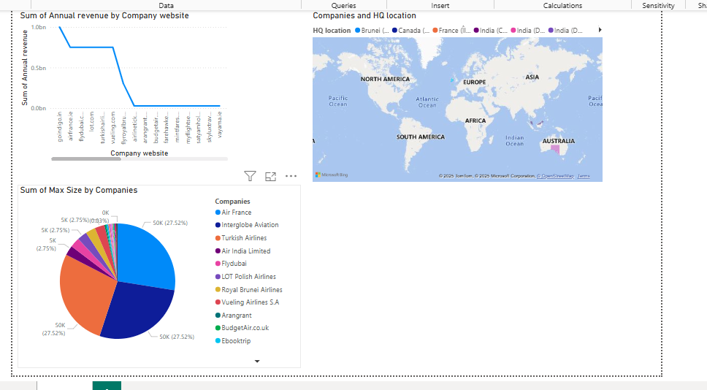



**Conclusion:**

Exploratory Data Analysis (EDA) and visualization are crucial for deriving insights from social media data. Various visualization techniques, such as **bar charts, line charts, heatmaps, and word clouds**, help businesses understand engagement patterns and audience behavior. Tools like **Power BI, Tableau, and Python** facilitate in-depth analysis and dashboard creation. By applying these techniques to Data Visualization, businesses can make data-driven decisions to enhance their social media strategy.